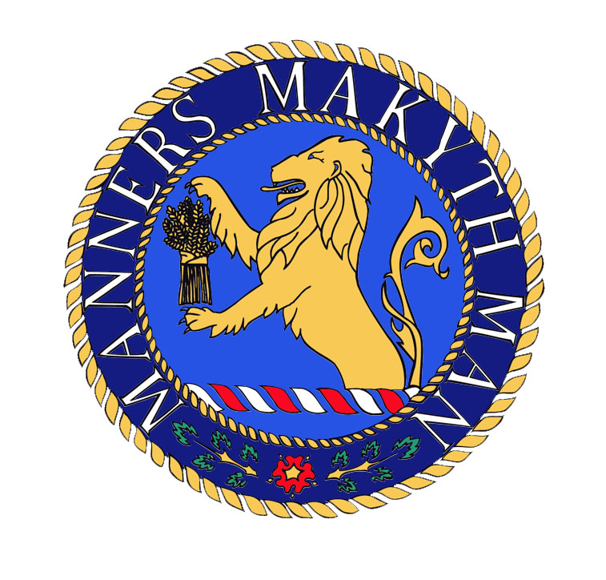
Year 7 Transition Task - Art & Design
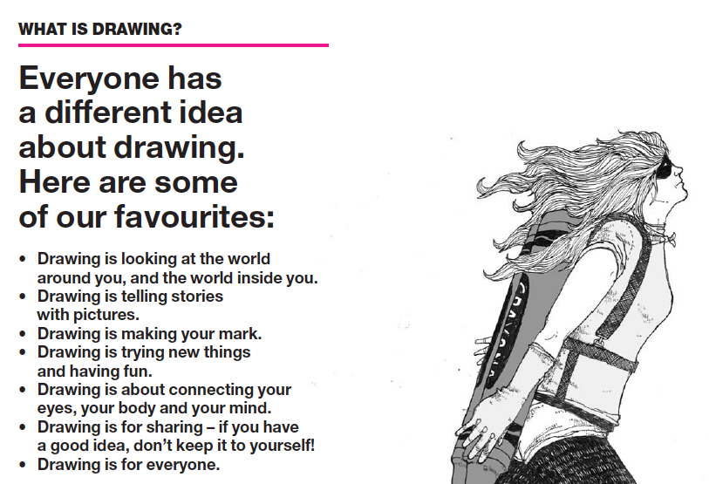

Like all great athletes training for their next competition, artists have to practice their skills too. Drawing little and often, at least once a day will help you improve quickly! Don’t be too critical of your skills at first and track your progress as you attempt each task.

Over summer, try out our 30-day drawing challenge. Don’t worry if you miss one, just move on to the next. Try to note down how long it took you to finish and if possible store them in a sketchbook.

Good Luck!

30 Day drawing challenge….



