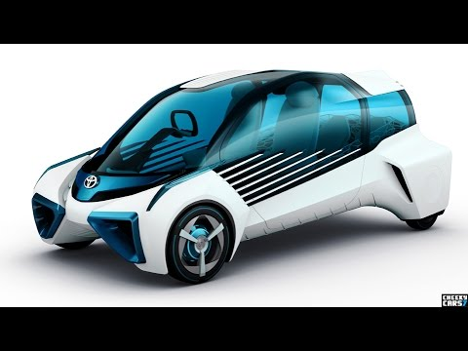
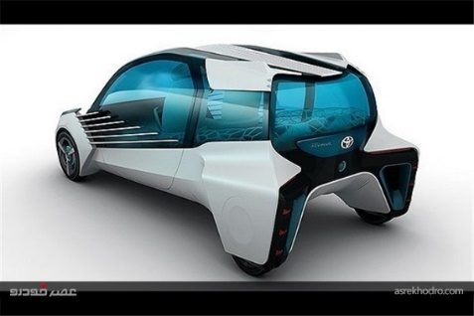
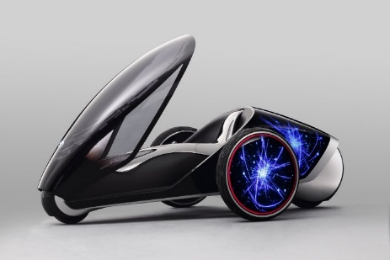
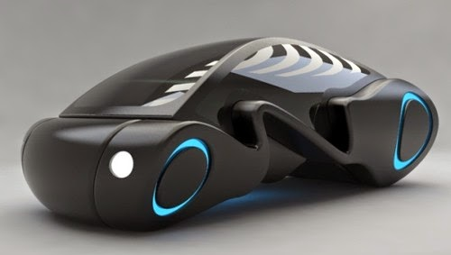
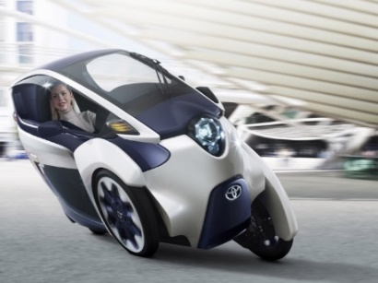
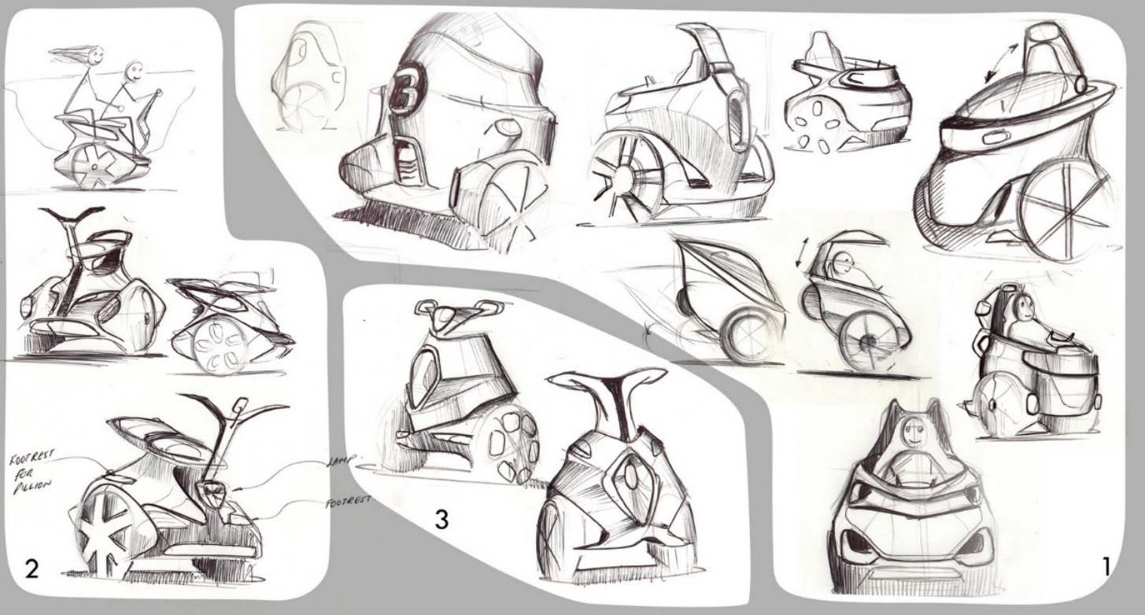

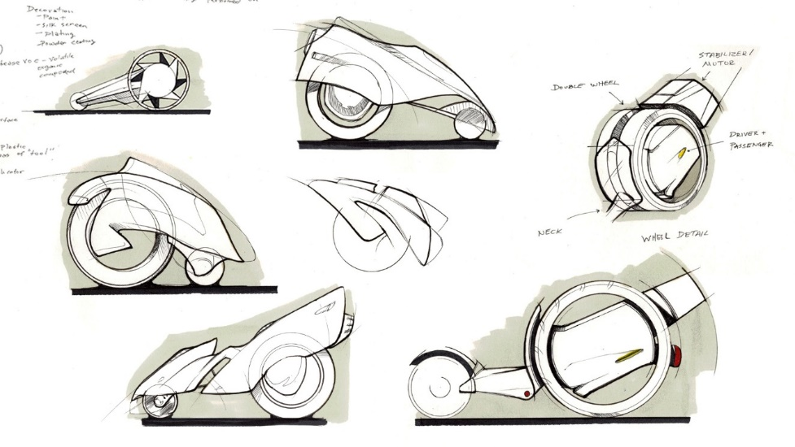
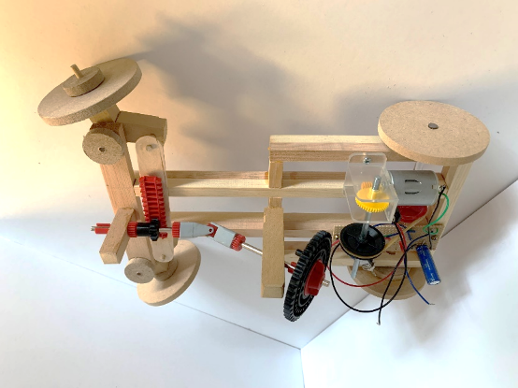
Year 7 Transition Task
Design and Technology

Taking inspiration from the images below, use notes and sketches to design a narrow, compact, one-person electric vehicle (like a motor bike/automobile hybrid) for modern City living.
Show where the driver sits, where luggage and a battery are stored, how it moves and steers, the bodywork and any other interesting, innovative details.

