
Year 7 Transition Task
Food & Nutrition

- Do you help prepare meals at home?
- Are you a keen baker?
- Can you make a mean Chilli?
- Do you have a signature dish?
- Please show us ……………

Your Task:
- Take a photograph of what you make/help to make at home.
- Complete a postcard to show what you have made. Add a photograph, your name and form and the name of the dish. You can complete more than one postcard.
- Bring your postcard with you in September.
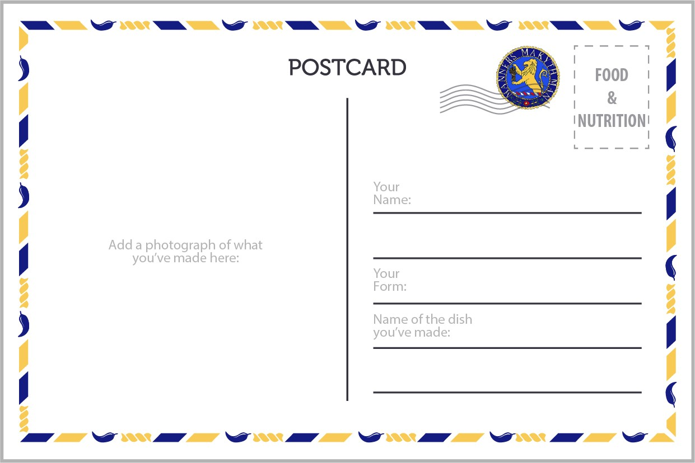
- Remember, you will need adult supervision for any making at home.

