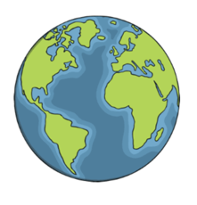

Urmston Grammar Geography Department
Transition Task

Name: ………………………………………………….. Form: 7……..

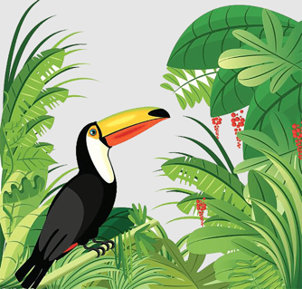
An introduction to your first topic…Tropical Rainforests!

When you join Urmston Grammar in September, one of your first Geography Topics will be looking at ‘Tropical Rainforests’. You will think about where they are found, why they are found there, what plants & animals live there as well as considering the impact humans have had on this precious environment.

In order to appreciate a tropical rainforest, and why it is special, it is useful to understand some of the other biomes that we have on the planet.

What does the word ‘biome’ mean?

……………..……………..……………..……………..……………..……………..……………..……………..……………..……………..……………..……………..……………..……………..……………..……………..……………..……………..……………..……………..……………..……………..……………..……………..
The World’s Biomes
Do you know: What are lines of latitude and longitude?
https://www.bbc.co.uk/bitesize/articles/zd4rmfr

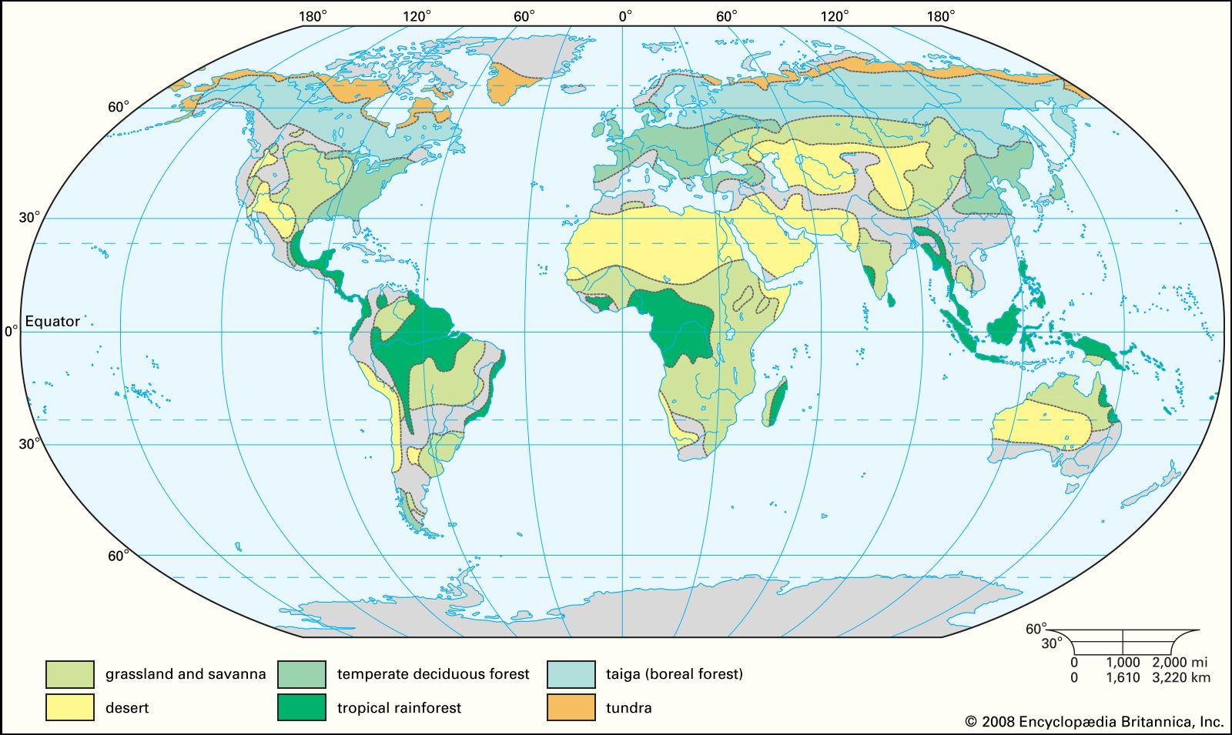
There are lots of different biomes around the world; each with their own climates, plants (also known as ‘flora’) and animals (also known as ‘fauna’). You’ll notice tropical rainforests are found in specific places. List the different places where tropical rainforests are found on this map. This could be continents, countries or regions.
………………………………………………………………………………………………………………………………………………………………………………………………………………………………………………………………………………………………………………………………………………………………………………………………………………………………………………………………………………………………………………………
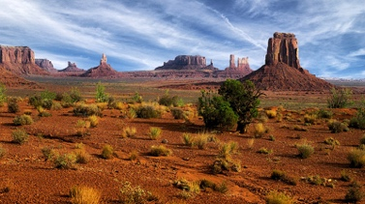
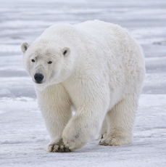
Research Task: Two Contrasting Biomes
Your research task is to find out about two different ‘biomes’.

Polar Hot Deserts

 | Polar | Hot Deserts
Location – Where are they found?

Climate – What is the temperature & rainfall like?

Flora (What are the plants like?)

Fauna (What are the animals like?)

How do humans use this environment? E.g., cities, settlements?

Bring all of your research to your Geography lessons in September, house points will be awarded for particularly interesting facts and thorough research.
You may also want to watch Planet Earth on BBC iPlayer Episode 1 (From ‘Pole to Pole’) 5 (Deserts) & 8 (Jungles).

