Urmston Grammar Maths



All the Maths teachers at Urmston Grammar are very much looking forward to meeting you. By completing this booklet you will be able to find out some facts about the Maths teachers at Urmston Grammar School and do some research into some of our favourite mathematicians.

There is a lot of content in this booklet – you should aim to complete a minimum of 3 of the pages.
Meet the department…

In the maths department we have 9 teachers. Throughout this booklet you will find out about some of our favourite maths related things. Can you fill in the blanks as you complete this booklet?
Mrs Kelly  Favourite Mathematician:  Favourite Number: | Mr Prastka  Favourite Mathematician:  Favourite Number:
Mr Watkinson  Favourite Mathematician:  Favourite Number: | Mr Tabor  Favourite Mathematician:  Favourite Number:
Miss Smith  Favourite Mathematician:  Favourite Number: | Miss Devenney  Favourite Mathematician:  Favourite Number:
Mrs Hodson  Favourite Mathematician:  Favourite Number: | Mrs Hunt  Favourite Mathematician:  Favourite Number:
Mrs Crouch
Favourite Mathematician:
Favourite Number:

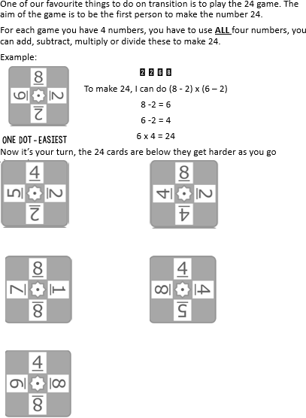
The 24 game…

You can play the following game with a friend, sibling, parent or carer. The aim of the game is to be the first person to make the number 24.

For each game you have 4 numbers. You have to use ALL four numbers. You can add, subtract, multiply or divide to make 24.

Mrs Hunt’s favourite number is the sum of 4 + 7

Miss Smith‛s favourite number is 70
divided by 5

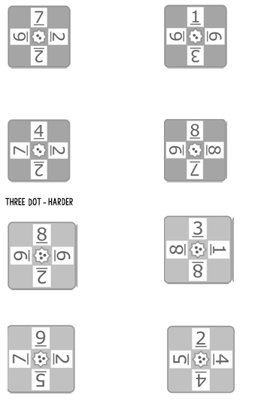

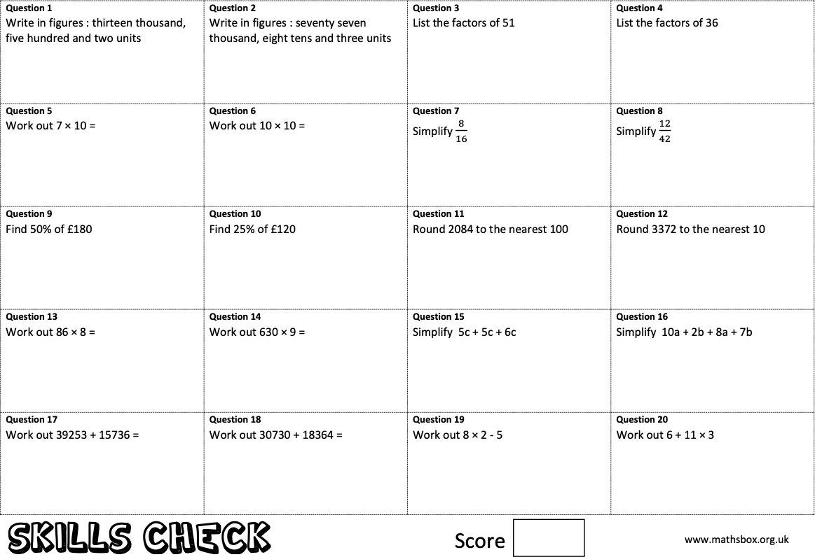
Key Skills…
Mr Tabor’s favourite number: $3^{2}+\sqrt{16}$

Spend 10 minutes completing the skills check questions based on topics from Year 6.

Mrs Kelly’s favourite Mathematician is Fibonacci who was an Italian man who studied maths and back in the 11th century. He discovered a pattern called the Fibonacci sequence. It is a series of numbers that starts with 0 and 1, and each number after is found by adding the two previous numbers. The sequence just keeps going on and on.
0, 1, 1, 2, 3, 5…
Can you find the first 10 numbers in the sequence?


Maths Keywords…
These are some of the important maths keywords that you will need to know. Can you find all the keywords you will need for your first half term at Urmston Grammar?
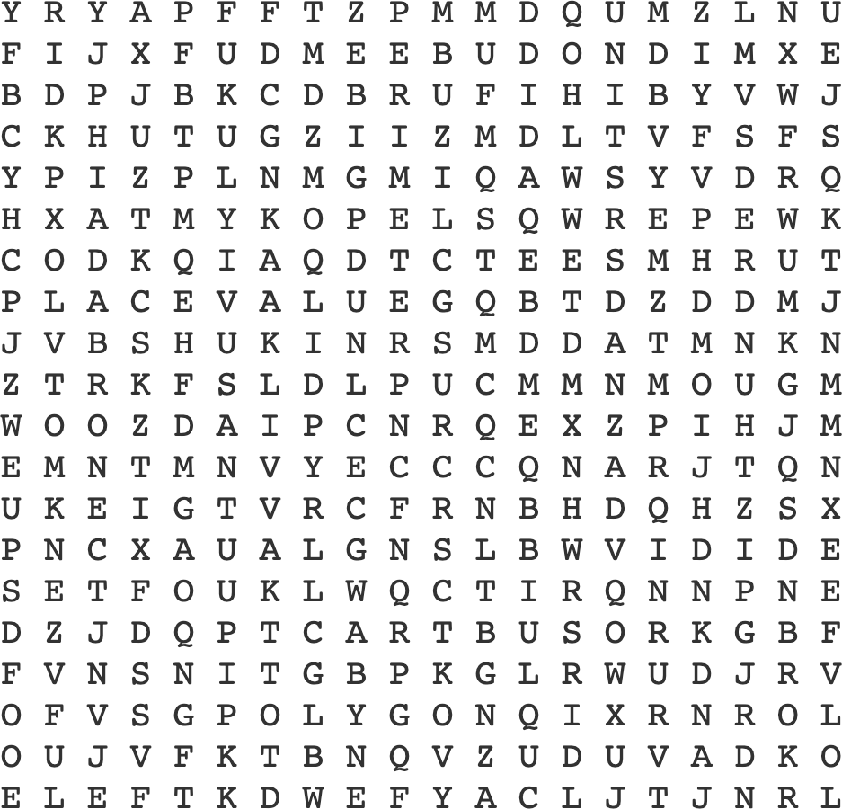

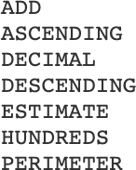
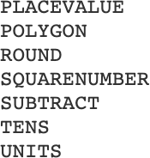

Mr Tabor’s favourite mathematician Leonhard Euler (pronounced Oiler) (April 15, 1707 – September 7, 1783) was a Swiss mathematician and physicist. He spent most of his life in Russia and Germany. Euler made important discoveries in fields like calculus and topology. He also made many of the words used in maths today.

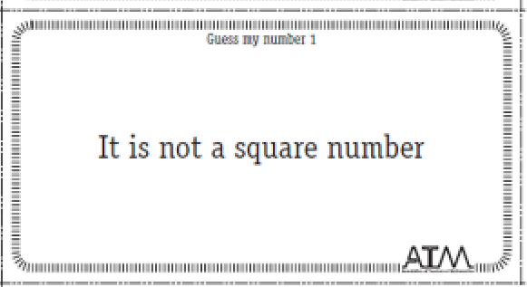
Mr. Prastka’s Favourite Number
Mr. Prastka has sent some clues to help work out his favourite number. Can you work it out?
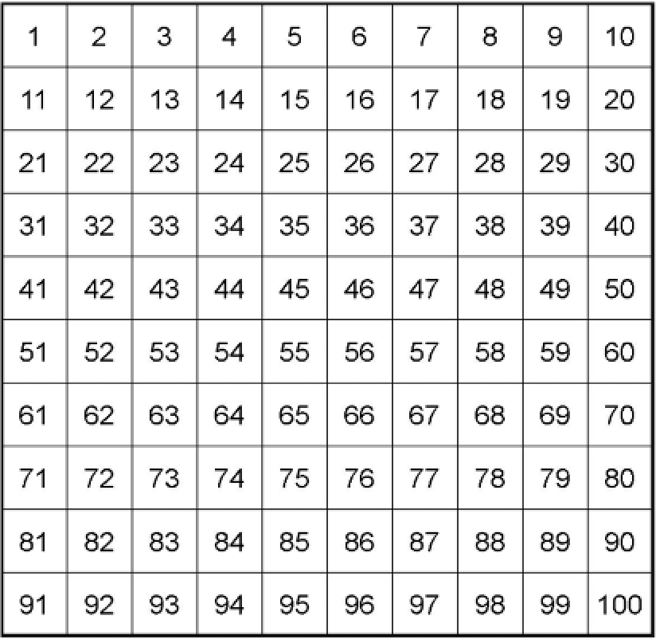
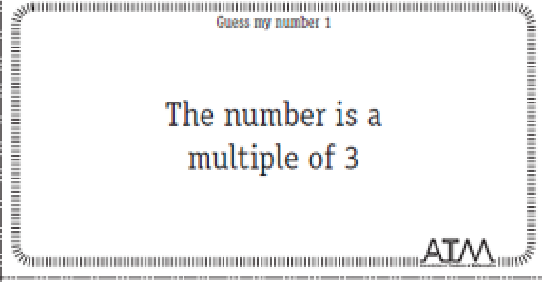
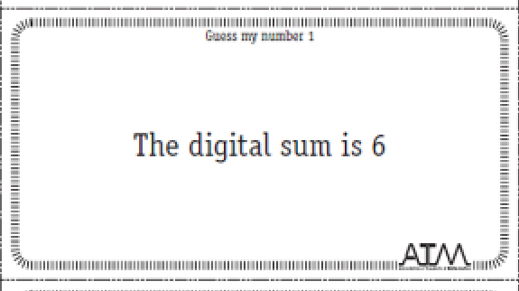
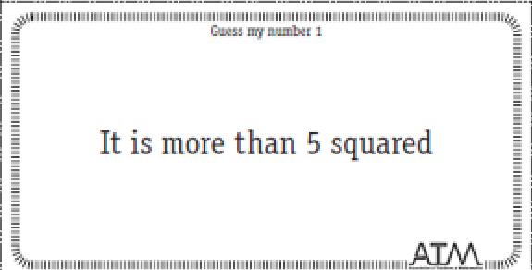
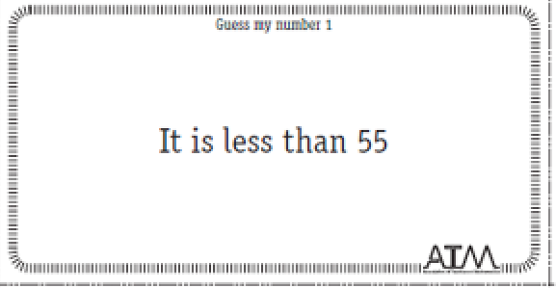
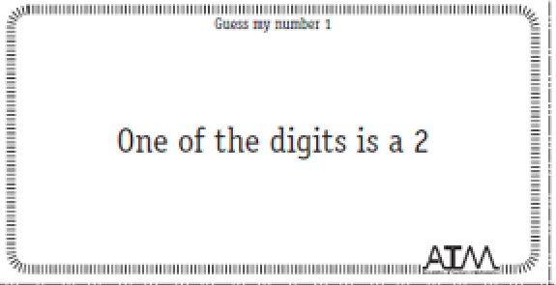
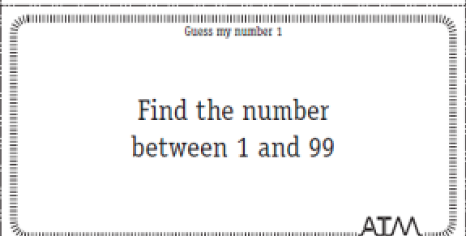

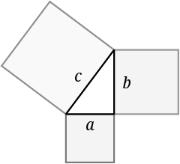
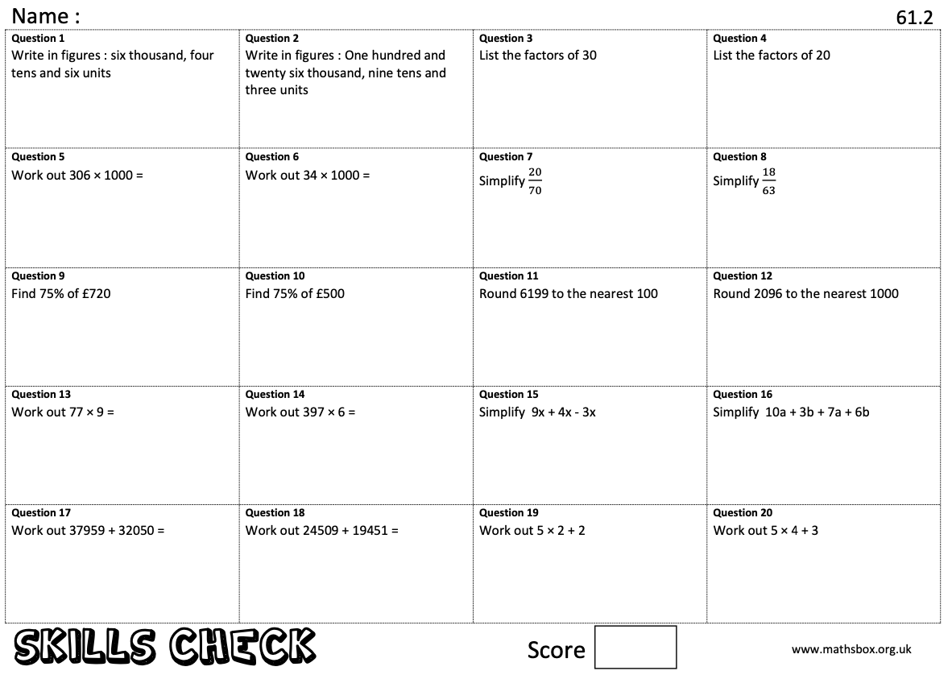
Key Skills…
Mr Watkinson’s favourite number is the product of 3 x 3 x 3

Spend 10 minutes completing the skills check questions based on topics from Year 6.

Mrs Hodson’s favourite mathematician
Pythagoras of Samos was a famous Greek mathematician and philosopher (c. 570 – c. 495 BC). He is known best for the proof of the important Pythagorean theorem, which is about right angled triangles. He started a group of mathematicians, called the Pythagoreans, who worshiped numbers and lived like monks.
Can you find out what the Pythagorean theorem is? You will use it in Year 9.

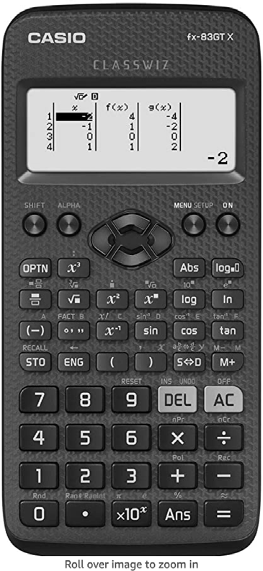
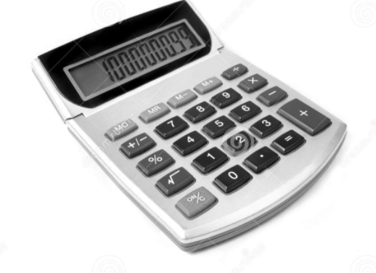
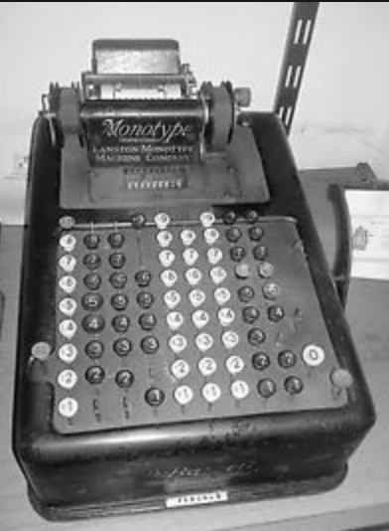
The calculator transformation
Blaise Pascal, in his short 39 years of life, made many contributions and inventions in several fields. He is well known in both the mathematics and physics fields. In mathematics, he is known for contributing Pascal's triangle and probability theory. He also invented an early digital calculator and a roulette machine.
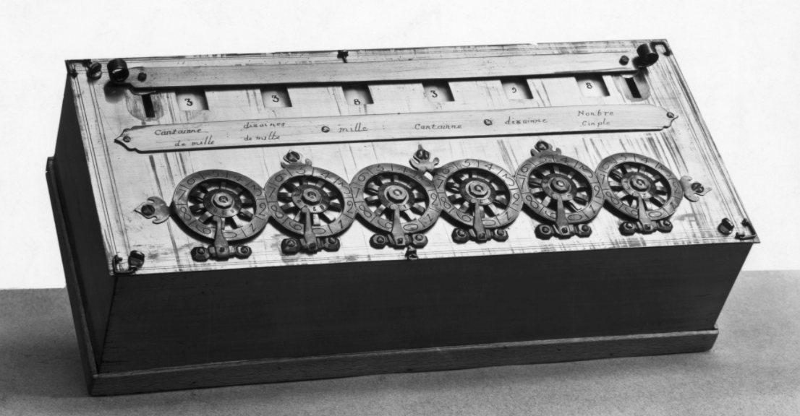
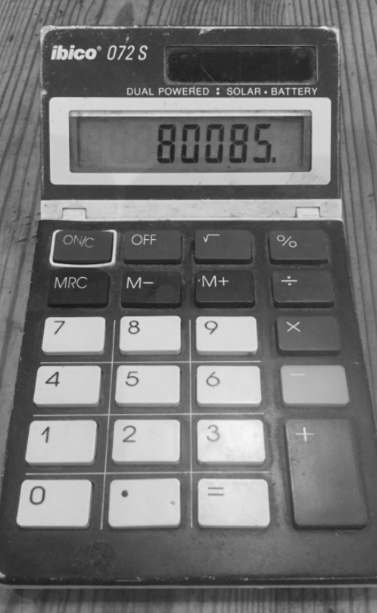
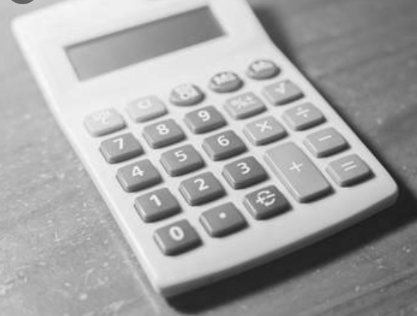
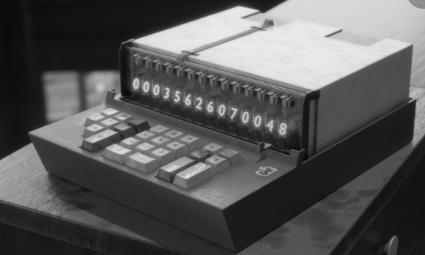
Pascal’s calculator

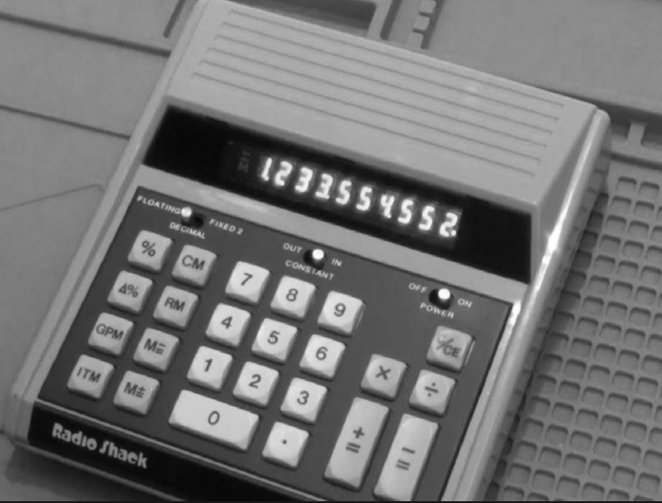
The calculator we use in school

The modern calculator can now be found everywhere, both mini and large versions and is embedded into devices such as laptops and mobile phones. How many devices that have calculators can you find in your house?

Miss Smith’s favourite mathematician

Mrs Crouch’s favourite number is the only even prime number
Code Breaking…
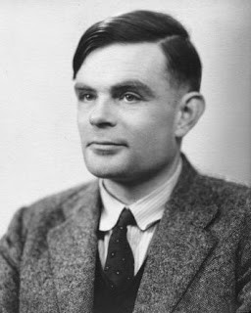
Alan Turing
Alan Turing was a British mathematician. He made major contributions to the fields of mathematics, computer science, and artificial intelligence. He worked for the British government during World War II, when he succeeded in breaking the secret code Germany used to communicate.
In September 1939 Great Britain went to war against Germany. During the war, Turing worked at the Government Code and Cypher School at Bletchley Park. Turing and others designed a code-breaking machine known as the Bombe. They used the Bombe to learn German military secrets. By early 1942 the code breakers at Bletchley Park were decoding about 39,000 messages a month. At the end of the war, Turing was made an Officer of the Most Excellent Order of the British Empire.
Can you crack the code to reveal the two Maths teachers whose favourite mathematician is Turing?

A | B | C | D | E | F | G | H | I | J | K | L | M
55 | 47 | 84 | 10 | 9 | 75 | 59 | 64 | 32 | 15 | 23 | 50 | 26
N | O | P | Q | R | S | T | U | V | W | X | Y | Z
80 | 63 | 19 | 3 | 27 | 30 | 21 | 92 | 18 | 35 | 99 | 69 | 199

$$5^{2}+1$$
$${10}^{2}-2^{3}$$
$$3^{3}$$
$$\left(5×6\right)-3$$
$$-5 ×-11$$
$$(20+3)×3$$
$${(-8)}^{2}$$
$$\left(3×3×10\right)+2$$
$$2^{3}×10$$
$$63÷3$$

Challenge: Can you make up some calculations to spell out your name using the same code breaker grid?


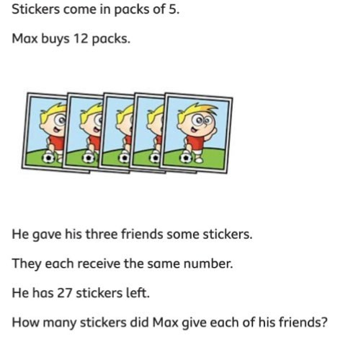
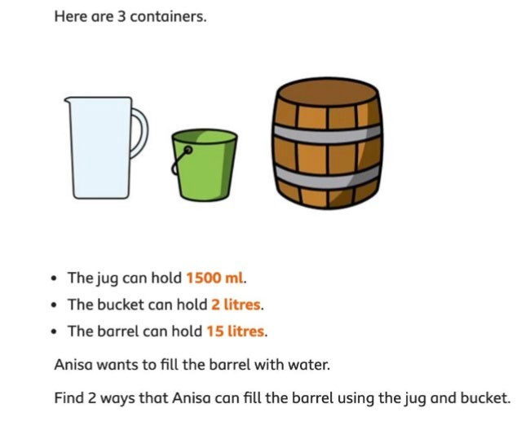
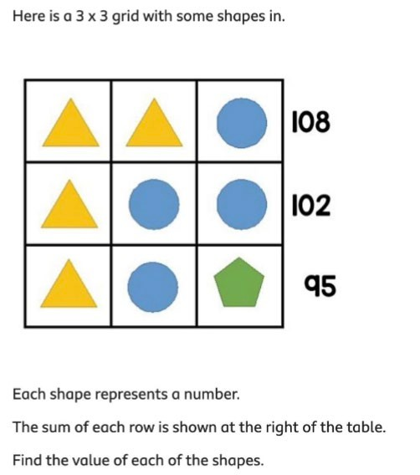
Maths Challenges

Can you solve all the Maths challenges? They get more difficult as you get them.

Mrs Hodson’s favourite number is 110

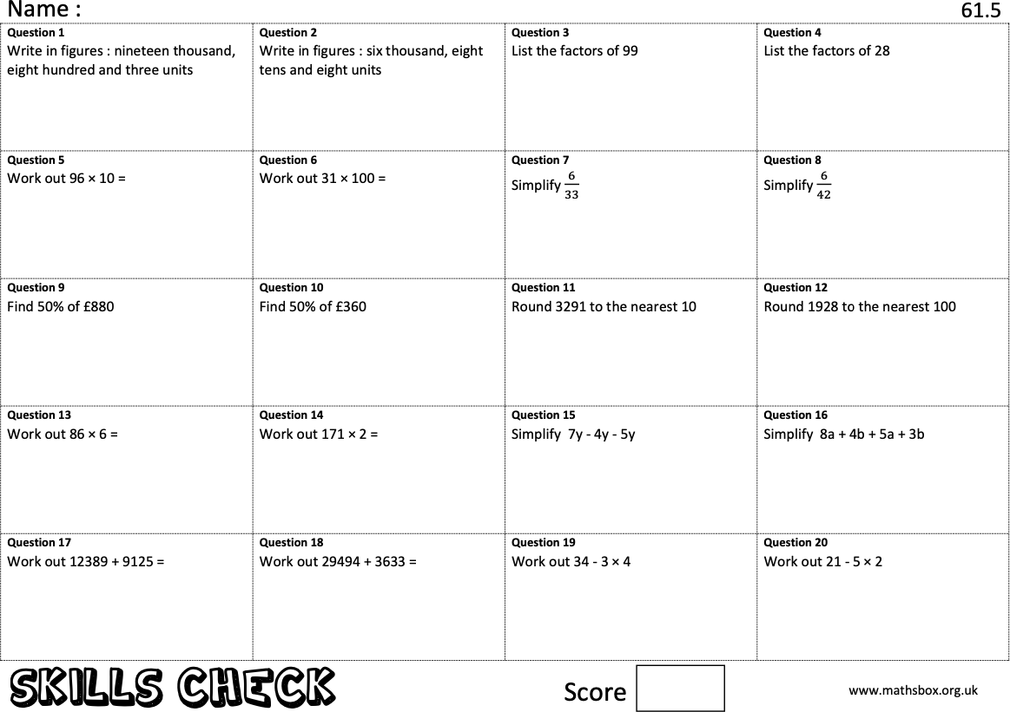
Key Skills…

Miss Devenney’s favourite number
is the 4th prime

Spend 10 minutes completing the skills check questions

Miss Devenney’s favourite mathematician is René Descartes
René Descartes

Descartes is considered the father of modern philosophy, a key figure in the scientific revolution of the 17th Century, and a pioneer of modern mathematics. Many people also call him the father of analytic geometry, which connects the fields of algebra and geometry.
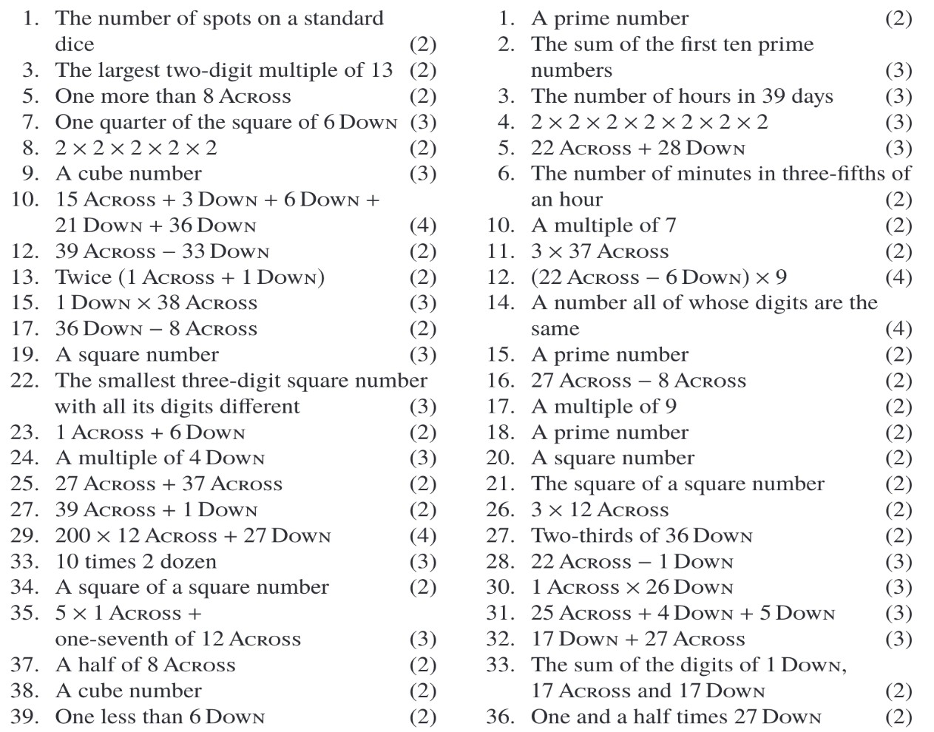
Cross Number…

Use the questions below to complete the cross number.

Mrs Kelly's favourite number is the answer to 4 down

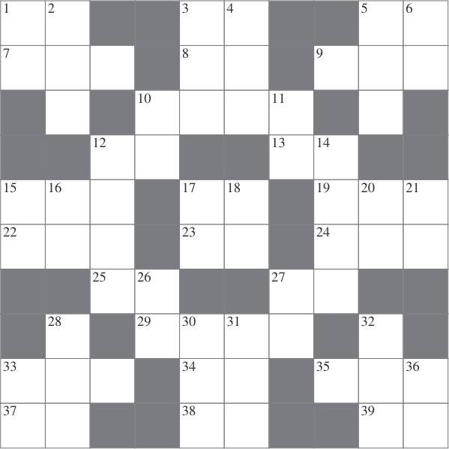
2
1

Across Down

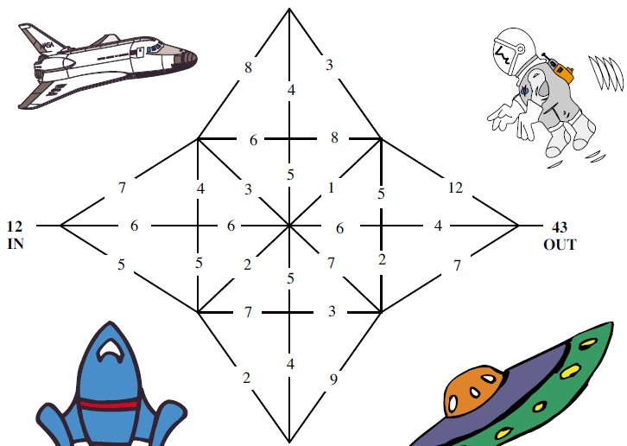
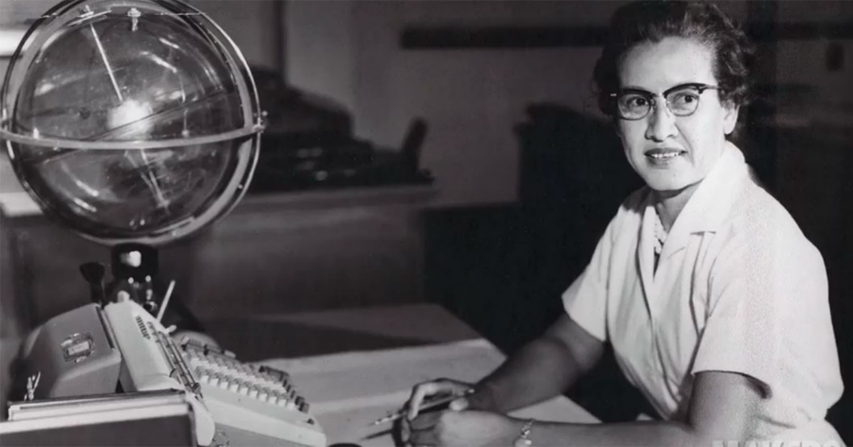
Star Maze…

Mr Prastka favourite mathematician is Katherine Johnson

Katherine Johnson
Katherine Johnson was an American mathematician whose calculations of orbital mechanics as a NASA employee were critical to the success of the first and subsequent U.S. crewed spaceflights.
Katherine Johnson helped to pioneer the use of computers to perform the tasks.
She was one of the first African- American women to work as a NASA scientist.
Start with the number at the entrance to the maze. Every time you go along a line you must add that number.
Enter the maze at IN and find a path OUT. No line can be visited twice.
Write down a path that gives you the correct out answer.


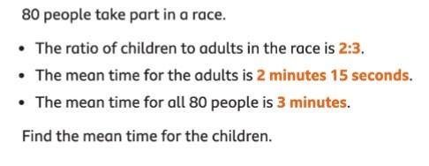
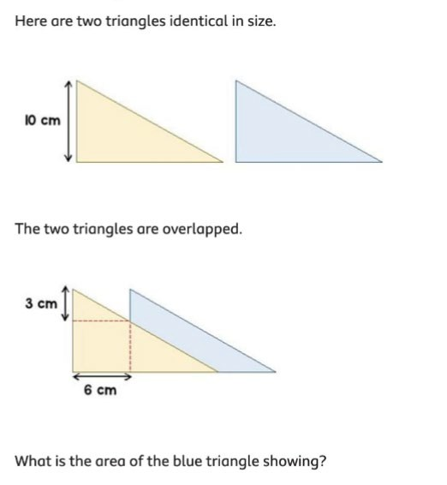
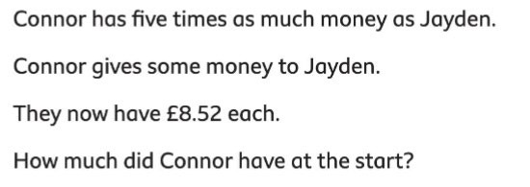
Maths Challenges…

Can you solve all the Maths challenges? They get more difficult as you get them.

We hope that you enjoyed these maths challenges. If you did, you can look forward to the Junior Maths Challenge that we run in school.

