

Wel
come to science at Urmston
Grammar!

We are really looking forward to
seeing you in September!

Hazards

Hazard Symbols are really important in science as they tell you if something can cause a danger to you or the environment around you! These are some common hazard symbols that you will see not only in science classrooms but you will also find some cleaners in your cupboards (like bleach) have hazard symbols on.

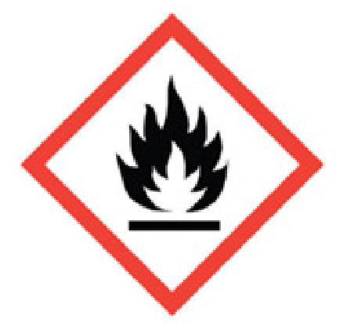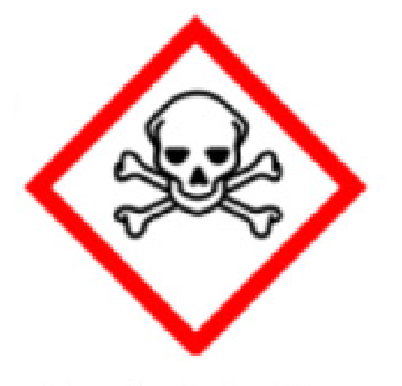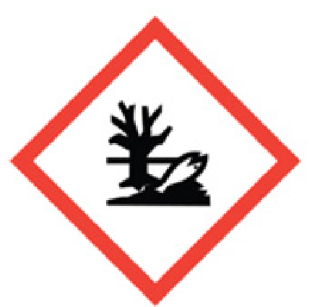
T
his is
means
“
flammable
.
”

This means
“
toxic
”

and
can kill if eaten or drank.

This means
“
harmful to
the environment.
”

You will notice that hazard symbols are clear and have no writing on them. This is so that they are easy to understanding by anyone. Currently we have symbol to show when a chemical is harmful to the environment (so kills plants and animals) but there isn’t a symbol for substances that are harmful to the atmosphere. For example, CFCs are chemicals in aerosols that are destroying the Ozone Layer. If the ozone layer is destroyed, more dangerous radiation will reach us from the sun!

Activity: You are going to design your own hazard symbol for “HARMFUL TO THE ATMOSPHERE” that could be used on dangerous aerosols. Remember that your hazard symbol should be:
- Clear with simple drawings
- No writing
- Surrounded in a red diamond shape

Underneath your hazard symbol write a few sentences to describe what you have drawn.

Design your hazard symbol on a piece of paper and bring it in to give to your new Science teacher in September.

