Maisie Devlin
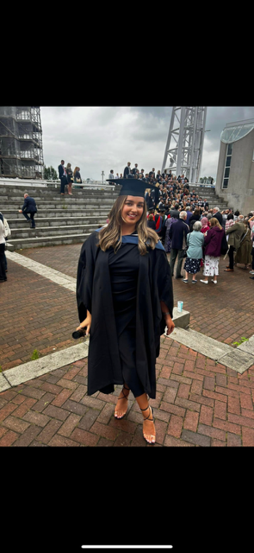
Name: Maisie Devlin
Employer: NHS, Trafford Community
Job Title: Occupational Therapy
Year Left UGS: 2021

What is the story of your career to date?
I studied at UGS from 2014 to 2021, and after completing my A-levels, I pursued a degree in Occupational Therapy at Salford University. During my studies, I worked as a carer for three years, which provided me with invaluable experience that I now bring into my role as an occupational therapist. Upon graduation, I applied for a rotation in Trafford, where I have the opportunity to work across different services every six months. I am currently on my first rotation within the Discharge to Assess team, a service designed to help people leave the hospital sooner by completing necessary assessments in their homes instead of in a hospital setting. The goal of this service is to ensure individuals can live independently at home with the appropriate support in place. My role involves conducting various assessments and providing individuals with the equipment and support services they need to live safely and independently. I work closely with a multidisciplinary team, including physiotherapists, nurses, and pharmacists, to deliver comprehensive care.
What subjects did you study at A Level at Urmston Grammar?
Psychology, Business Studies, Religious Education
How do you feel your subjects/time at Urmston Grammar prepared you for this career?
I chose my A levels based on my genuine interests and the subjects I knew I would enjoy. With a clear intention to pursue a career in Occupational Therapy, I made sure to choose subjects that aligned with the entry requirements, which included a science. Fortunately, psychology was classified under social sciences, which allowed me to meet the criteria while still studying a subject I was passionate about.

What does a typical day look like for you?
The day begins with a morning handover, where we review any new referrals and discuss the patients currently on our active list. Afterward, we each take on a caseload of patients to visit that day. We typically work independently, in the community where we conduct assessments and providing interventions as needed. In some cases, we may refer patients to other relevant teams or professionals, such as social workers, GPs, or carers, to ensure comprehensive care. At the end of the day, we complete our visit documentation, order necessary equipment, and manage referrals and other paperwork.
What skills do you think are important in your role?
Teamwork, problem solving, communication, compassion.
What advice would you give to someone who wants to do your job?
My advice would be to focus on gaining as much hands-on experience as possible, whether through volunteering, working as a carer, or shadowing professionals in the field. This experience not only helps you understand the practical side of the role, but it also deepens your empathy and communication skills, which are essential in this line of work. It's a rewarding job, but it can be demanding at times, so having a passion for helping others and a good sense of resilience will help! Be a sponge… absorb all the knowledge and experiences you can, don’t expect to know everything at the start learn from others and share your ideas!!
Does your employer offer volunteering/apprenticeship opportunities?
Volunteering opportunities may be available.
What is the best thing about your job?
The best thing about my job is the direct impact you have on people’s lives. Helping individuals regain their independence, stay at home safely, and improve their quality of life is incredibly rewarding. Every day brings new challenges and the opportunity to make a real difference.
Where can I find out more?
University of Salford website and NHS careers.

