SEDONA GROVES – SUSTAINBILITY AND CLIMATE CHANGE
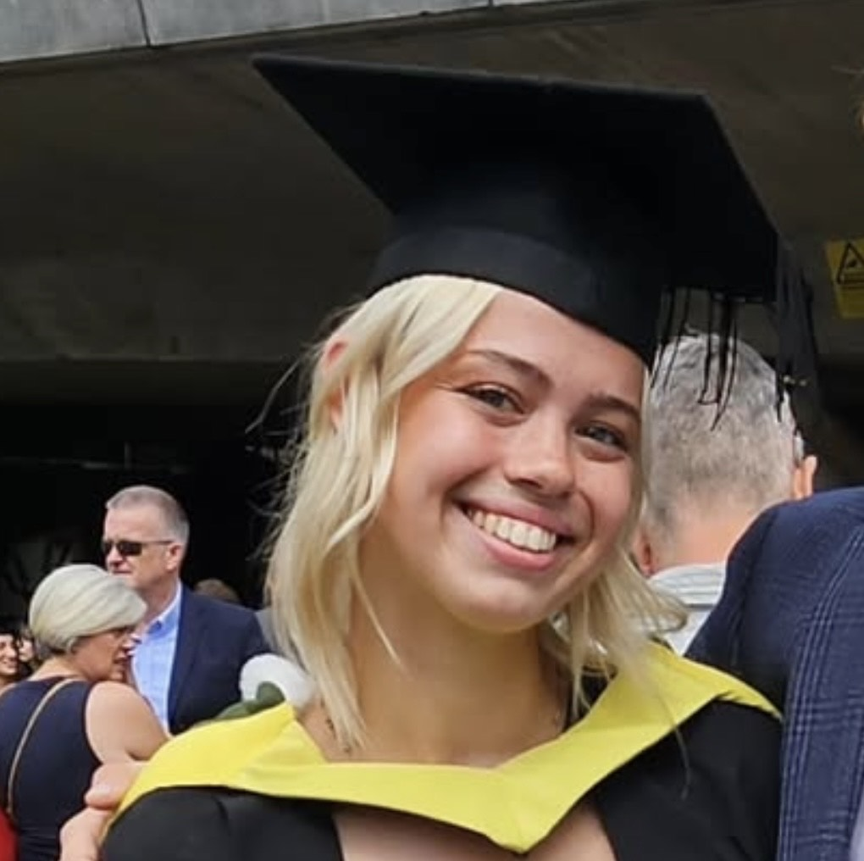
Name: Sedona Groves
Employer: WSP
Job Title: Sustainability Consultant
Year Left UGS: 2021

What is the story of your career to date?
I completed a BSc in Environmental Science at the University of Sheffield, graduating in 2024 with First-Class Hons. Prior to starting my career in Sustainability in September 2024 at WSP, I took two months to travel post-university. During my time at university, I worked various hospitality and retail jobs and completed two internships specific to my degree – one as a research assistant for the University of Manchester and the other as an undergraduate Sustainability and Climate Change Consultant at WSP. The internships helped consolidate the idea that I wanted to work in a fast-paced, varied environment where I was able to implement solutions to the various challenges I had studied and researched within my degree.
My role at WSP is diverse; I work with multiple clients across both the public and private sectors, including mining, nuclear, energy, infrastructure, and legal services, aiding with environmental assurance and providing insights into areas such as sustainability practices, regulatory frameworks, and risks associated with climate change. There is also scope to work across sectors, so I have been able to work with the Energy team and Transformation Advisory on different projects. I have also enrolled onto the Chartership programme with the support of WSP for the Institute of Environmental Management and Assessment (IEMA) to advance my professional recognition and sector-specific knowledge.
What subjects did you study at A Level at Urmston Grammar ?
Biology, Chemistry, Psychology and EPQ
How do you feel your subjects/time at Urmston Grammar prepared you for this career?
I chose subjects that supported a career in the medical science pathway rather than picking what I enjoyed at GCSE as I wanted to do something in bio-sciences– originally, I was going to opt for Geography, German and Psychology! Psychology was a fresh subject at A-level, and I was pleased with my choice as it complimented my other two options very well, as well as forming the basis for my EPQ. I did my A levels during COVID which made them much harder with the uncertainty, however I still came out with useful skills which were translated into my degree and my career. In retrospect, I have found A-Level Psychology is incredibly useful for Environmental Science and in general; it helped me develop strong analytical and communication skills which I use daily. As an interdisciplinary subject, it prepared me to combine knowledge of principles from several sectors to produce an outcome designed to exceed client expectations.
The support I received during my A-levels was instrumental and has helped shape the success I have achieved so far, personally, academically and within my career.

What does a typical day look like for you?
Every day is different, and my role is very flexible. My day typically involves team meetings, client communication, project work like research and data analysis, stakeholder meetings, business development tasks, and administrative duties. Collaboration with colleagues and continuous learning about sustainability trends are also key aspects of the role. I have the opportunity to work away from the office – such as on a client visit, working on site, participating in a volunteering day, or even secondment. I actually really enjoy my job and the structure it offers, as well as the social opportunities outside of work with colleagues.
What skills do you think are important in your role?
There are many I use daily, but the most important are:
- Data Analysis: Interpreting data (qualitative and quantitative).
- Communication: Explaining sustainability concepts; relaying ideas and solutions successfully and succinctly.
- Problem-Solving: Developing innovative solutions for clients and for internal work.
- Stakeholder Engagement: Persuading and collaborating.
- Technical Knowledge: Understanding environmental science principles (inc. biochemistry, GIS modelling, physical geography etc.).
What advice would you give to someone who wants to do your job?
- Gain Relevant Education: Pursue a degree you’re passionate about in a related field to build a strong foundation of knowledge.
- Develop Key Skills: Focus on developing analytical, communication, problem-solving, and stakeholder engagement skills.
- Get Practical Experience: Seek internships, volunteer opportunities, or entry-level positions in sustainability to gain hands-on experience.
- Stay Informed: Keep up with the latest trends, regulations, and technologies in sustainability by reading industry publications and attending conferences or webinars.
- Network: Build a professional network by connecting with other sustainability professionals and joining relevant organizations or groups.
- Certifications: Consider obtaining certifications in sustainability or environmental management to enhance your credentials.
- Be passionate! You definitely get more out of this career if you’re inspired to make a difference and coordinate change.
Does your employer offer volunteering/apprenticeship opportunities?
Yes we do – definitely Summer Placements and a Year in Industry (only available at university) – there may be availability for apprentices.
What is the best thing about your job?
I expand my knowledge every day, and am constantly surrounded by new people and developing new skills. It’s lovely to see a project from inception to close and to help build sustainable solutions to support the transition to a greener future
Where can I find out more?
Visit WSP website (https://www.wsp.com) and look at ‘Careers’, ‘Job Opportunities’, ‘Who We Are’ and ‘What We Do’ or search us on LinkedIn.

