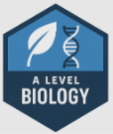

Urmston Grammar Sixth Form
Transition Work Biology Department

Lesson activity: GCSE to A-level progression (Biology)

Student booklet with information about:
- the specification and structure of the assessment
- and key skills activities to support the move from GCSE to A-level Biology.

Contents | Page
Understanding the specification and the assessment | 3
Transition activities 1-3: Scientific vocabulary | 8-10

Aim of the booklet
This booklet will support your transition from GCSE science to A-level. At first, you may find the jump in demand a little daunting, but if you follow the tips and advice in this guide, you’ll soon adapt. As you follow the course you will see how the skills and content you learnt at GCSE will be developed and your knowledge and understanding of all these elements will progress.

We have organised the guide into two sections:
- Understanding the specification and the assessment
- A transition activity to bridge the move from GCSE to start of the A-level course

Understanding the specification and the assessments
Specification at a glance
The specification is a useful reference document for you. You can download a copy from our website here.
The most relevant parts of the specification for students are the following:
Section 3: Subject content
Section 6: Maths requirements and examples
Section 7: Practical assessment

In Biology, the subject content is split between year 12 content (sections 3.1 – 3.4) and year 13 content (sections 3.5-3.8). The section titles are listed here:

  - Biological molecules
  - Cells
  - Organisms exchange substances with their environment
  - Genetic information, variation and relationships between organisms
  - Energy transfers in and between organisms (A level only)
  - Organisms respond to changes in their internal and external environments (A level only)
  - Genetics, populations evolution and ecosystems (A level only)
  - The control of gene expression (A level only)

Each section of the content begins with an overview, which describes the broader context and encourages an understanding of the place each section has within the subject. This overview will not be directly assessed.

Assessment structure
The assessment for the A-level consists of three exams, which you will take at the end of the course.
Paper 1
What's assessed
- Any content from topics 1-4 including
relevant practical skills
How it’s assessed
- Written exam: 2 hours
- 91 marks
- 35% of the A-level
Questions
- 76 marks: a mixture of short and long answer questions
- 15 marks: extended response questions

Paper 3
What's assessed
- Any content from topics 1-8 including
- relevant practical skills
How it’s assessed
- Written exam: 2 hours
- 78 marks
- 30% of the AS-level
Questions
- 38 marks: structured questions, including practical techniques
- 15 marks: critical analysis of given experimental data
- 25 marks: one essay from a choice of two titles

Paper 2
What's assessed
- Any content from topics 5 – 8 including
relevant practical skills
How it’s assessed
- Written exam: 2 hours
- 91 marks
- 35% of the A-level
Questions
- 76 marks: a mixture of short and long answer questions
- 15 marks: extended response questions

Assessment objectives

As you know from GCSE, we have to write exam questions that address the Assessment objectives (AOs). It is important you understand what these AOs are, so you are well prepared. In Biology there are three AOs.

- AO1: Demonstrate knowledge and understanding of scientific ideas, processes, techniques, and procedures (A-level about 30-35% of the marks).
- AO2: Apply knowledge and understanding of scientific ideas, processes, techniques, and procedures;
- in a theoretical context
- in a practical context
- when handling qualitative data
- when handling quantitative data
(A-level about 40-45% of the marks).
- AO3: Analyse, interpret, and evaluate scientific information, ideas, and evidence, including in relation to;
  - make judgements and reach conclusions
  - develop and refine practical design and procedures
(A-level about 25–30% of the marks).
Year 12 Biology Transition Tasks

Task 1 – The structure of microscopic organisms
For each of the following sketch a labelled diagram of each structure.
Drawing Biological Structures

- Biologists DO NOT need to be artists! However, diagrams are an important part of practical work.
- CLEAR and ACCURATE LINE drawings are preferable to rough sketches and over elaborate shaded pictures.
- It should be possible to make the drawing clear with the use of THICK and THIN LINES and careful CROSS-HATCHING.
- Labelling of your diagrams is really important.
- Labels should be connected to the appropriate part of the diagram with a clear, straight line.

Don’t rely on your GCSE knowledge – Research each structure using A level websites eg Physics & Maths Tutor, Save My Exams or try Crash course biology on you tube.

Try to create complete diagrams that include all the parts cells can include.

Where there is variation, sketch a couple of common examples.

Viruses

Prokaryotic Cells

Eukaryotic Cells

Task 2 – The Function Cellular Structures

For each part, find out the function and identify if it is present in Eukaryotes, Prokaryotes or Viruses. The first has been done for you.

Name of Structure | Function | Present in which type(s) of organism (Virus/Prokaryote/Eukaryote)
Capsid | A capsid is the protein shell of a virus, enclosing its genetic material. Its functions include:  - protect the genome,  - deliver the genome  - Binding with host cells.  They come in many shapes including; helical, polyhedral and complex shapes like bacterial phages. | Virus
Capsule
Cell Membrane
Cell Vacuole
Cell Wall
Chloroplasts
Flagella
Golgi Body
Lipid Envelope
Lysosomes
Mesophyll
Microvilli
Mitochondria
Nucleus
Plasmid
70s Ribosomes
80s Ribosomes
Rough Endoplasmic Reticulum
Smooth Endoplasmic Reticulum

Task 3 - Biological Molecules

For each of the following Draw a Stick diagram (think Chemistry) the first one has been done for you.

Bio Molecule | Diagram | Bio Molecule | Diagram
Alpha- glucose | 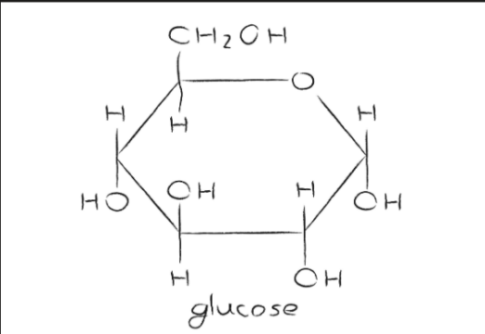 | Beta-glucose
Fructose |  | Sucrose
Maltose |  | Amino Acid
Triglyceride |  | Phospholipid

Task 4 – Biochemical Tests

Complete the table to summarise the tests for each biochemical substance (the first has been completed for you).

Substance | Test Name | Method | Negative result | Positive result
Starch | Starch Test | - Use water to produce a solution  - Add 5 drops of iodine  - Mix | Brown/orange solution | Blue-black solution
Protein
Reducing sugar
Non- reducing Sugar
Lipid

